The microclimate effects and responses of Mormon tea (*Ephedra californica)*

Team Name: Mad Tea Party

Amy Forsythe

Sam Gene

Jonas Lafave

Baris Uzel

**Background:** Climate is one of the most popular environmental topics in recent times. There are many individuals and organizations that are eager to understand how changing climates will affect our resources and the habitats of species across the globe (Bernauer and Gampfer, 2013). However, there are fewer people discussing microclimates. As the climate changes, how are the conditions of the habitats of smaller species affected? If a shrub or tree shades the ground beneath it, this creates a microclimate which could be cooler or moister due to decreased impacts of solar radiation and evapotranspiration (Charles et al. 2020; dos Santos et al. 2020; Michopoulous et al. 2020). This in turn can impact nutrient availability, microbial communities and soil quality, diversifying the number of abiotic and biotic factors in a region (Charles et al. 2020; dos Santos et al. 2020; Michopoulous et al. 2020).

*Ephedra californica* shrubs are a locally dominant species in California deserts (Lortie et al. 2018). They are used in agriculture, medicine, oil and gas production, and are a contender for sustainable energy development (Lortie et al. 2018). Their microclimate is also important in providing shelter from environmental conditions to the blunt-nosed leopard lizard (*Gambelia sila*), an endangered species in California (Nobel 2017). Many species of shrub have been observed to grow back larger after harvest or herbivory which may increase the area of their microclimates, providing more shelter to lizards and more crop for harvest (Dangerfield and Modukanele 1996; Wandera et al. 1992; Willard and McKell 1978). In some cases, increased harvest management regime may be beneficial to local economies and species.

**Data Description:** The dataset for this project was provided by Dr. Christopher Lortie. Measurements were taken from shrub microsites in the Cuyama Valley, California. The focal shrub species is Mormon tea (*Ephedra californica*). The dataset contains 1,107,452 rows and 20 columns, where rows are observations and the columns are different categories of data. Shrub volume (*V*) will be calculated using the mutate() function in dplyr. See Appendix for full description.

GitHub will be used to share all code as it is created: [https://github.com/J0nasML/Biol-812](https://github.com/J0nasML/Biol-812?fbclid=IwAR1XYLTc-EWJOVxypkGdWC85IA_5YH8QgrpzAEfX6jEhAM5cybUIRox-Xyo)

**Do latitude, longitude, shrub volume, and treatment affect microsite temperature and soil moisture? If so, how does this effect vary over a season?:** We will run a general linear model in R with mean temperature as the response variable and latitude, longitude, shrub volume, microsite and treatment as predictor variables. As we expect temperature to increase at decreased latitudes, we will also run the model without latitude as a predictor. Latitude, longitude and shrub volume (see Appendix) are continuous numerical predictor variables, while treatment (clipped vs. unclipped) and microsite (open vs. shrub) are categorical predictors. Mean temperature is a continuous numerical response variable. We will repeat the analysis with mean soil moisture as the continuous response variable. To assess the changes in microclimate over time, we will create a time series visualization using ggplot2. Mean soil moisture and temperature will be examined over time (measured in months), allowing us to see seasonal fluctuations.

**Pipeline:** The first task will be to filter the dataset to ten columns, and two rows for each shrub (one row for the open microsite and one row for the shrub microsite). The columns that will be kept are shrub ID, x, y, z, treatment, latitude, longitude, microsite, mean temperature and mean soil moisture. We can use the dplyr package (functions select and filter) or base R to do this filtering, and to calculate mean temperature and mean soil moisture for each shrub and microsite type. The next step is to check for any bias in sample sizes among predictor variables and to check for missing data. We will check for correlations among predictors before running our linear model, using either the cor() function or the corrplot package.

For both mean temperature and mean soil moisture, our initial model will consider the main effects and interactions between each of our five predictors. The lm() function in R will be used to form all models, where the input consists of the predictors and response variable. The output will be obtained from summary(). Model selection will be conducted using *α=0.05* as a threshold to obtain final models with statistically significant predictors of mean temperature and soil moisture. The final step to our linear model will check whether assumptions are met. The importance of the outputs is summarized in the appendix. Visualizations include box plots, dot plots, scatterplots and interaction plots from the ggplot2 package or base R. ggplot2 will be used to compare treatments and microsite conditions over time.

**Does the effect of treatment on shrub volume vary geographically?:** We will run an ordinary least square (OLS) linear model in R testing the relationship between shrub volume as the response variable and treatment, soil moisture, temperature, elevation, latitude and longitude as predictor variables. Treatment is a categorical predictor (clipped vs unclipped), while latitude, longitude, soil moisture, elevation, and temperature are continuous numerical predictor variables. Shrub volume is a continuous numerical response variable. In order to account for spatial heterogeneity, we will use a geographically weighed regression (GWR) with the statistically significant predictors from our OLS model. The traditional OLS model assumes that the regression model is true for the entire study area. However, due to spatial variations in predictors, this assumption is often invalid. GWS allows us to spot predictors that effect the response variable differently in different conditions. For example, in areas with higher temperature, soil moisture might have a stronger influence on shrub volume compared to relatively colder areas. By applying a GWR, we can understand whether the effects of our predictors change spatially.

**Pipeline:** An OLS regression will be performed as outlined above. Following a check for assumptions, the statistically significant predictors will be used in a GWR, using the GWmodel package in R. If soil moisture is a significant predictor, we will reclassify it as dry, moist, or semi-arid using the dplyr package. The rest of the data will be put into the ggwr function as is. The results will be visualized using the ggmap package in R. Points representing individual shrub observations will be assigned different colours according to their volume size. These point representations will be underlain by a density map showing the spatial variations on predictor effect. For example, areas where soil moisture strongly effects shrub volume would be red whereas, areas where soil moisture does not affect volume would be blue.

**Predictions:** We predict that mean temperature will be lower (Figure 1) and mean soil moisture will be higher in the shrub microsite compared to the open microsite, due to the shade that the shrubs provide. However, the strength of this effect may depend on the conditions within a season. If clipped shrubs over-compensate their growth (Dangerfield and Modukanele 1996; Willard and McKell 1978) and achieve higher volumes (Figure 2), then we expect lower mean temperatures and higher mean soil moisture content in the clipped treatment. We predict that mean temperature will increase and mean soil moisture will decrease with decreased latitude, due to the increased amount of sunlight. We expect this effect of latitude on mean temperature and mean soil moisture to interact with longitude, since longitude may influence local climate variables including rainfall and wind.

**Significance**: To implement a harvest strategy, it is important to understand how microclimates change according to site coverage. What are the differences in temperature and soil moisture depending on the range of coverage of the shrubs? Does the increased volume of regrown harvested shrubs impact the microclimates, and therefore available habitats, in the region? These factors may change over time space, depending on the season and geographic region, impacting the applicability of resource management regimes to different areas. Since *Ephedra californica*, shrubs can be used by society for a wide range of purposes, it is important to understand how harvest in different regions impacts its microclimates.

**Responsibilities**: Baris will lead the GWR and associated spatial data transformations. Amy is responsible for data acquisition and will lead the linear model. Jonas is responsible for GitHub repository set up and poster layout. Sam will lead the time series and is responsible for editing and formatting. Everyone will contribute to analysis and visualization, while taking direction from section leads.

**References**

Bernauer, T., and R. Gampfer. 2013. Effects of civil society involvement on popular legitimacy of global environmental governance. Global Environmental Change 23:439–449.

Charles, S. P., J. S. Kominoski, A. R. Armitage, H. Guo, C. A. Weaver, and S. C. Pennings. 2020. Quantifying how changing mangrove cover affects ecosystem carbon storage in coastal wetlands. Ecology 101:1–18.

Dangerfield, J. M., and B. Modukanele. 1996. Overcompensation by Acacia erubescens in Response to Simulated Browsing. Journal of Tropical Ecology 12:905–908.

Hardt Ferreira dos Santos, V. A., G. S. Modolo, and M. J. Ferreira. 2020. How do silvicultural treatments alter the microclimate in a Central Amazon secondary forest? A focus on light changes. Journal of Environmental Management 254:1–9.

Lortie, C. J., E. Gruber, A. Filazzola, T. Noble, and M. Westphal. 2018. The Groot Effect: Plant facilitation and desert shrub regrowth following extensive damage. Ecology and Evolution 8:706–715.

Michopoulos, P., K. Kaoukis, G. Karetsos, T. Grigoratos, and C. Samara. 2020. Nutrients in litterfall, forest floor and mineral soils in two adjacent forest ecosystems in Greece. Journal of Forestry Research 31:291–301.

Noble, T. J. 2017. Habitat association patterns of an endangered lizard species with a foundation plant species in the San Joaquin Desert of California: radio telemetry as an ecological tool. York University.

Wandera, J. L., J. H. Richards, and R. J. Mueller. 1992. The Relationships between Relative Growth Rate, Meristematic Potential and Compensatory Growth of Semiarid-Land Shrubs. Oecologia 90:391–398.

Willard, E. E., and C. M. McKell. 1978. Response of Shrubs to Simulated Browsing. The Journal of Wildlife Management 42:514–519.

**Appendix**

**Data Description:** The dataset for this project was provided by Dr. Christopher Lortie, who is a professor in the Department of Biology at York University. The meanings of the “code” and “logger.ID” columns could not be recalled by Dr. Lorite. A summary for the remaining columns is provided below.

The first column is the site number. There is a total of six sites, represented by numbers 1-6. The second column gives the shrub ID, for a total of 31 Mormon tea shrubs. The next three columns are x, y and z, which measure the longest length (as seen from above), the length perpendicular to the longest length, and the height of the shrub, respectively, in metres.The next two columns provide the latitude and longitude of each of the six sites. The following column gives the sensor ID, for a total of62 Hobo micro-station data logger weather stations. Four additional sensors were added due to replacements.Skipping over the “codes” column, the next four columns show the year, month, day and hour of the day (from a 24-hour clock) that the measurements were taken. The columns “Type.sensor” and “sensor” are repeat columns, conveying whether the sensor collected temperature or soil moisture data. Temperature data was collected 15cm above the soil in degrees Celsius from two 12-Bit temperature smart sensors at each station. Soil moisture data was collected as volumetric water content (VWC, the ratio of water volume to soil volume) from two EC5 soil moisture smart sensors at each station. The “measure” column provides the temperature or soil moisture reading and the “status” column indicates whether the sensor is the original or was replaced. The “treatment” column reveals that this dataset covers two treatments: shrubs that were previously clipped and allow to regrow, and unclipped shrubs. Finally, the “microsite” column reveals whether temperature and soil moisture measurements were taken from the shrub or open microsite. Each shrub microsite reading is paired with an open microsite reading within 1m of the shrub.

Elevation data for the GWR will be outsourced. We will use a 90m digital elevation model from the NASA Shuttle Radar Topographic Mission (SRTM), clipped to the study area.

Link:  <http://srtm.csi.cgiar.org/srtmdata/>

**Volume Calculation:** Shrub volume (*V*) will be calculated using *x*, *y* and *z* and the formula for volume of a semisphere (Lortie et al. 2018):

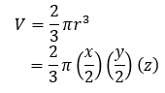

where *x* and *y* are divided by 2 as the length in the dataset is diameter.

**Linear Model Output:** The important output statistics are the p-values for our main effects and interactions, *r2*, adjusted *r2* and the F-statistic and p-value for the model. The *r2* value provides a measure of how much variation in mean temperature/mean soil moisture is explained by our final model, while the adjusted *r2* can be compared to the original full model to determine how the model’s fit to the data changes between models. The F-score and p-value for the final model will tell us whether there is a statistically significant relationship between our response variable and the remaining predictors.

When it comes to assumptions, we will need to check for normality of residuals and homogeneity of variance across residuals. We can also check for outliers that have a strong influence on the model. The plot(), plot_model() (from the sjPlot package) and shapiro.test() functions can be used for this task.

**Prediction Figures**

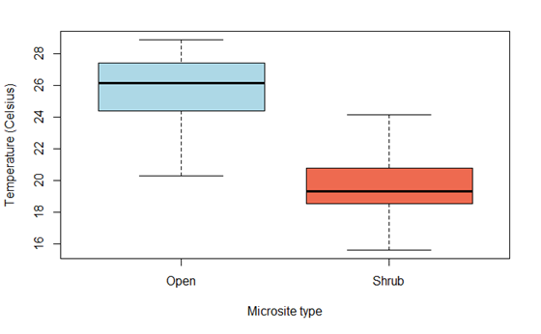

**Figure 1.** Example of a boxplot showing that temperature (in °C) is, on average, higher in open compared to shrub microsites.

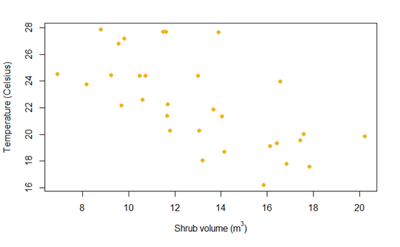

**Figure 2.** Example of a scatterplot showing that temperature (in °C) is, on average, higher in microsites where shrubs have lower volumes.